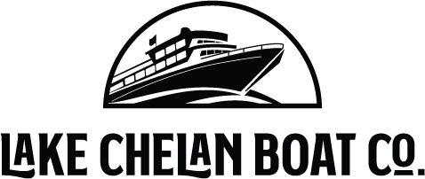

Lake Chelan Boat Company

P.O. Box 1057
Chelan, WA 98816

Public Notice
The following requests have been submitted to the Washington Utilities & Transportation Commission for their approval.
February 16, 2024
To whom it may concern,

This notice is to inform you that Lake Chelan Boat Company has submitted a request to the Washington Utilities & Transportation Commission for the following time schedule changes.

- Removing the Lady of the Lake service on Mondays from the Monday after Memorial Day through Labor Day, due to low ridership. This cuts 13 days of service.

Lake Chelan Boat Company will continue to adjust and provide the best run schedules and safest public transportation on Lake Chelan. Decisions will continue to be made based on essential travel, supply needs and the safety of passengers and crew.

If you have questions or concerns, please email info@ladyofthelake.com or phone 509-682-4584. If you have questions or concerns that you would like to address with the UTC, phone 888-333-9882 or email comments@utc.wa.gov.

Sincerely, Sincerely,
Reed Courtney Brun Garfoot
Reed Courtney Brun Garfoot
Discover Lake Chelan, LLC-Managing Member Discover Lake Chelan, LLC-Managing Member

